**Finding Areas of Rectilinear Figures: Part Two**

(This task builds from Finding Areas of Rectilinear Figures: Part 1)

*Adapted from North Carolina Department of Public Instruction*

**Student Objective:** “I can find area of a large rectilinear figure by decomposing the figure into smaller rectangles.”

|  |  |
| --- | --- |
| **Common Core Standards to Measure** | **Mathematical Practices Addressed** |
| **3.MD.7** Relate area to the operations of multiplication and addition.  **d.** Recognize area as additive. Find areas of rectilinear figures by  decomposing them into non-overlapping rectangles and adding the areas of the non-overlapping parts, applying this technique to solve real world problems. | #7 Look for and make use of structure.  #8 Look for and express regularity in repeated reasoning. |

**Materials:**

Grid paper

Square tiles, large construction paper

Scenario

|  |  |  |
| --- | --- | --- |
| G  **Engage Students with the Goal** | State and Rate  Objective: “I can find area of a large rectilinear figure by decomposing the figure into smaller rectangles.”  Students rate themselves to the goal (1, 2, 3, 4). | Setting Objectives and Providing Feedback |
| A  **Access Prior**  **Knowledge** | Ask students, “What did we do yesterday to find the area of complex figures?” Have students pair-share and write down what they remember in their interactive notebooks. | Summarizing and Note-Taking  Cooperative Learning |
| N  **New Information** | In the previous lesson, students found the areas of rectilinear figures by breaking the figure into two rectangles. In this lesson, students will find the areas of even more complex figures. These figures may be broken into more than two rectangles.  The Areas of Complex Figures I sheet should be reviewed and discussed before beginning this lesson.  1. Display and read the opening problem to the class. Jaxon is replacing the carpet in his bedroom. His bedroom is shaped like this:  How can Justin find the amount of carpet he needs to order?  **Discuss the figure:**  • How is this shape like the ones used yesterday for area?  • How is this shape different from the ones we used yesterday?  • How do you suppose we find the area of this figure?  **Find the area of the figure:**  • Allow students to count aloud as each square unit is identified in the figure.  • Where can I break this figure apart into rectangles? Allow students to suggest horizontal or vertical lines and draw them on the figure.  • How can I now find the dimensions and areas of the rectangles? Choose one student for each step of the process: find the length, find the width, Calculate the area. Record each step on the board or document projector. This calculation should be displayed during the student activity for reference.  • Now I have **three** areas. What can I do to find the area of the whole figure?  • How can I check my work?  **4. Probe:**  • Is there another way I could separate the rectangles? Turn and talk to a partner about a different wayto separate the rectangles.  • Have volunteers or choose students to demonstrate two additional ways of separating the figure into rectangles and calculating the area. | Identifying Similarities and Differences  Providing Feedback  Homework and Practice  Cooperative Learning  Reinforcing Effort and Providing Recognition  Nonlinguistic Representations |
| A  **Application** | The Areas of Complex Figures sheet provides practice working towards the stated goal of the lesson.  Only the first two problems should be completed during this phase of the lesson. The third problem will be completed after the discussion.  **Introduce the activity:**  • Today, you will continue to work on finding the areas of figures with only right angles. With a partner, you will find two **different** ways to break apart the figures to calculate their areas. You will record one way on your paper, and your partner will record another way. Only work on problems 1 and 2 at this time.  • It may be necessary to demonstrate the procedure for the activity.  Facilitate the activity:  • Assign pairs or allow students to choose partners.  • Encourage students to use colored pencils, markers, or crayons on the grids for their solutions to easily be seen.  • As students are working, visit each pair to monitor the understanding of directions, answer any questions, watch for different problem solving strategies, identify interesting figures, and listen for misunderstandings or difficulties. Also, ensure students label each rectangle with its dimensions.  Suggested questions to ask as students work:  • How are you determining the amount of carpet?  • How can we use what we know about covering rectangles to help us?  **Debrief:**  Choose a student to display their work and explain their solution to problem 1 with the class.  **Discuss:**  • Who solved the problem by making different rectangles? Allow volunteers or choose students to share their solutions on the document projector. Raise your hand if you solved the problem like ____________.  • Is there another way to break apart the figure?  **Repeat for Problem 2.**  If any further misunderstandings or difficulties were observed while students were working, address them here.  **Problem 3** on the Areas of Complex Figures II sheet can be broken into three or more rectangles, depending on how students visualize the problem. Allowing students to work independently first provides the teacher with information about individual student thinking. Sharing strategies in pairs exposes students to others’ thinking and reasoning. The discussion exposes students to the thinking of several students.  **Continue the discussion with students:**  Some complex figures can be broken into more than three parts.  • Look at problem number 3. Think about a way to break that figure into three or more parts. Allow about 30 seconds thinking time.  • Draw your divisions and find the area. Allow about 3 minutes for students to complete the problem.  • Now you will find someone who broke the apart the figure in a different way. Decide who will be Student A and who will be Student B.  **Student A** will share their solution first, then **Student B.**  Allow about 2 minutes for pairs to share.  Choose 4 or 5 solutions to be displayed at the same time by overlapping the papers, covering problems 1 and 2.  • How are these solutions alike?  • How are the solutions different?  • How can we check to be sure the area is correct?  **Math Journal**  Have students complete the following prompt with at least two complete sentences on the back of the  Areas of Complex Figures II sheet or in a Math Journal:  • The part of today’s lesson I understood best was __________ because ____________. The part of today’s lesson that I am still confused about is ___. |  |
| G  **Revisit the Goal** | Have students write a statement of learning in their interactive notebooks/journals using words and pictures. Have students share their entry with other students.  State and Rate  Objective: “I can find area of a large rectilinear figure by decomposing the figure into smaller rectangles.”  Students rate themselves to the goal (1, 2, 3, 4). | Setting Objectives and Providing Feedback  Summarizing and Note-Taking |

**Math Journal (Interactive notebooks)**

Have students write a statement of learning in their interactive notebooks/journals using words and pictures. Have students share their entry with other students.

**Elaborate on the lesson:**

The Elaborate portion refocuses the students to use rectangular arrays to demonstrate area. Ask students: Suppose Mrs. Comfort wanted all of her tables touching in arrays.

1. What is the fewest who could come to dinner? (10)

2. What is the most who could come to dinner? (14)

3. What do you notice about the array that seats the fewest and the array that seats the most? The array with the fewest seats is clustered together. The array with the most seats is more spread out.

**Evaluation:**

**Formative**- As students work, pose questions and observe them to check for their understanding.

**Summative-** Students’ work from the elaborate section can be used as a summative assessment

**Plans for Individual Differences:**

**Intervention**- Provide scaffolding questions for the students, reminding them to think step-by-step when solving these types of problems.

• Can we cut the figure into smaller pieces?

• How can we find the areas of the smaller pieces?

• What can we do with the areas of the smaller pieces to find the area of the larger figure?

Students who exhibit significant difficulties may still need to count the square units to find area or reproduce the figures using cubes or tiles to identify the smaller rectangles.

**Extension-** Have students cut 2 copies of complex rectilinear figures from centimeter grid paper and mount on index cards. Students should mount one copy on the front of the card. The second copy should be mounted on the back of the card. Students should show one way to find the area of the figure and record on the back of the card. Keep the cards in a center for the class.

**Opening Problem – Finding the Areas of Complex Figures II**

**Jaxon is replacing the carpet in his bedroom. His bedroom is shaped like this:**

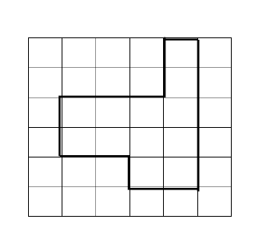

**How can Jaxon find the amount of carpet he needs to order?**

Name_________________

Areas of Complex Figures II

A. Separate each figure into rectangles.

B. Label the dimensions of the rectangles.

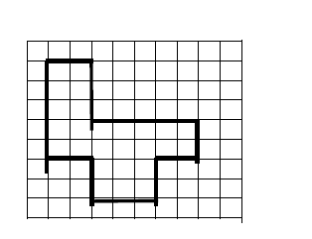C. Find the area of the figure.

Stephanie is replacing the tiles on her bathroom floor. How many square units of tile should Stephanie buy?

Area________

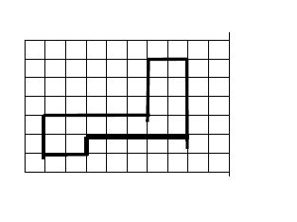

Jordan is mowing Mrs. Nelson’s

lawn. How many square units

must Jordan mow?

area________

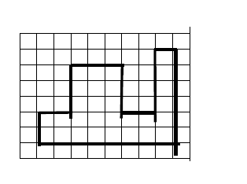

Mr. Simms is replacing the floor in

his home. How many square units

of flooring should he buy?

area________

**Area and Perimeter Problem Solving**

Draw each solution. Circle A for area or P for perimeter. Write the answer on the line.

|  |  |
| --- | --- |
| 1. A farmer needs to buy fencing to go around his garden. The garden is a 20’ by 15’ rectangle. How much fencing will he need?   A or P Answer ________________ | 2. Mrs. Thomas bought a rectangular rug that was 2 feet long by 3 feet wide. What is the area of the rug?  A or P Answer ________________ |
| 3. Mr. Dodson wants to fence an area that is 8 feet by 10 feet. How much fence will he need?  A or P Answer ________________ | 4. Sara wants to buy wood to make a frame for her picture. Her picture is a 12” by 10” rectangle.  What is the total length of the wood strips she  will need for her project?  A or P Answer ________________ |
| 5. A certain wall is 13’ by 9’. A can of paint will  cover 50 square feet. Will it be enough?  Explain.  A or P Answer ________________ | 6. The Leckworth family wants to put tile on their bathroom floor. Each tile is 1 foot square. Their bathroom is 4 feet by 6 feet. How many tiles will be needed?  A or P Answer ________________ |